**DAILY ONLINE ACTIVITIES SUMMARY**

|  |  |  |  |  |  |  |  |  |
| --- | --- | --- | --- | --- | --- | --- | --- | --- |
| **Date:** | **26/05/202** | | | | | **Name:** | **Anjali Manohar Prabhu** | |
| **Sem & Sec** | **4th Sem Section - ‘A’** | | | | | **USN:** | **4AL18CS007** | |
| **Online Test Summary** | | | | | | | | |
| **Subject** | | **DESIGN AND ANALYSIS OF ALGORITHMS** | | | | | | |
| **Max. Marks** | | **30** | | **Score** | | | **25** | |
| **Certification Course Summary** | | | | | | | | |
| **Course** | **INTRODUCTION TO R** | | | | | | | |
| **Certificate Provider** | | | 1. **Great Learning Academy** | | **Duration** | | | **2.5hrs** |
| **Coding Challenges** | | | | | | | | |
| **Problem Statement: 1.** Write a c program to print all permutation of a given string using pointers | | | | | | | | |
| **Status: Completed** | | | | | | | | |
| **Uploaded the report in Github** | | | | | **YES** | | | |
| **If yes Repository name** | | | | | [**https://github.com/vinisharen/lockdown-coding**](https://github.com/vinisharen/lockdown-coding) | | | |
| **Uploaded the report in slack** | | | | | **NO** | | | |

Online Test Details: DAA online test was conducted on date 26/05/2020 from 9:15 to 10:00 on the topic “Divide and Conquer” ”Decrease and Conquer Approach”. There were 30 question in total where each question consist of 1 mark

Certification Course DetailsA quick **introduction to R**. '**R**' is a programming language for data analysis and statistics. It is free, and very widely used by professional statisticians. ... It has many built-in functions and libraries, and is extensible, allowing users to define their own functions and procedures using **R**, C or Fortran.

Snapshot:

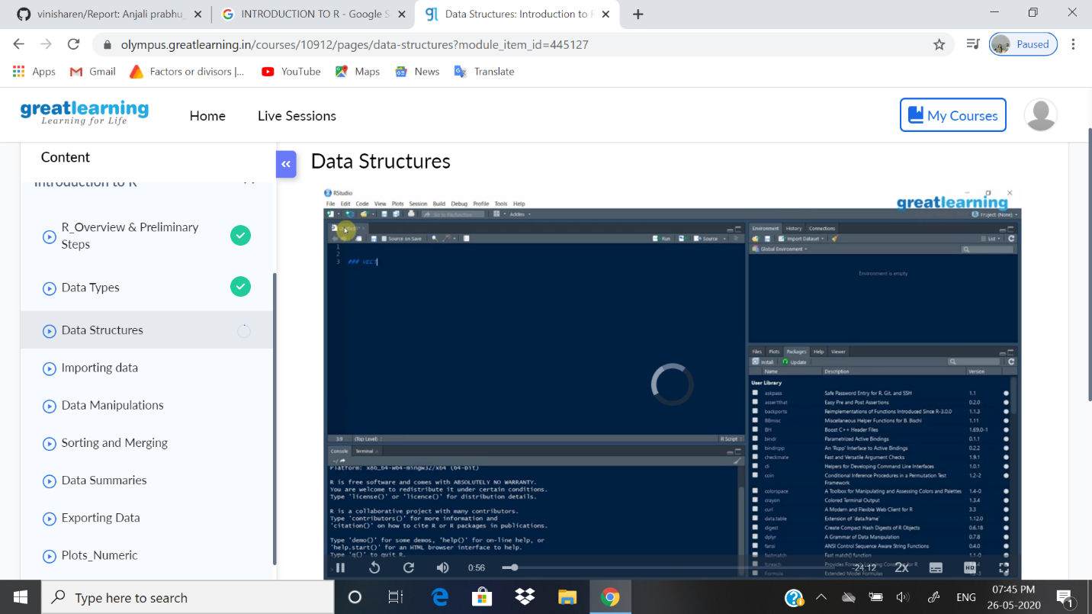

ONLINE CODING DETAILS:

PROBLEM 1: Write a c program to print all permutations of a given string using pointers

SNAPSHOT: